**Technical & Financial Proposals**

**for**

**Leasing & Integrated Accounting System**

*Prepared for*

**Meghna Solar Limited**

**(ZH Group BD Ltd)**

House No-560 (6th Floor),

Road No-08, Adabor,

Baitul Aman Housing Society

Dhaka, Bangladesh

**August 16, 2014**

*Submitted by*



**Ethics Advanced Technology Ltd.**

House#9 (5th floor), Road#16   
Gulshan-1, Dhaka-1212, Bangladesh   
Phone: +88-02-9860590, Fax: +88-02-9860863   
Website: [www.eatlbd.com](http://www.eatlbd.com)

***TABLE OF CONTENTS***

Page

A. ORGANIZATIONAL PROFILE AND EXPERIENCE OF EATL 5

A.1 ABOUT EATL 5

A.1.1 FOCUS AREAS 5

A.1.2 GROWTH AND STRATEGIC EXPANSION OF EATL 6

A.2 LIST OF MAJOR SOLUTIONS DEVELOPED BY EATL 6

A.3 SUCCESSFUL EXPERIENCES OF EATL IN BANGLADESH 8

A.4 REFERRED CLIENT LIST 15

A.5 LEGAL DOCUMENTS 15

A.6 FINANCIAL CAPABILITY AND COMMITMENTS 16

A.7 CORE SERVICE AREAS 16

A.8 EATL INDUSTRY EXPERIENCE 16

B. DETAILED METHODOLOGY 17

B.1 HOW DO WE WORK 17

B.2 PHASES OF DEVELOPMENT 18

B.2.1 ENVISIONING PHASE 18

B.2.2 PLANNING & DESIGN PHASE 19

B.2.3 DEVELOPMENT PHASE 22

B.2.4 STABILIZATION PHASE 23

B.2.5 DEPLOYMENT PHASE 24

B.2.6 TRAINING PHASE 25

B.3 PROJECT MANAGEMENT METHODOLOGIES AND FRAMEWORK 25

B.3.1 AGILE DEVELOPMENT MODEL (SCRUM) 26

B.3.2 PROTOTYPING MODEL 26

B.3.3 INCREMENTAL METHODOLOGY 27

B.3.4 SPIRAL MODEL 27

B.4 PROJECT MANAGEMENT PLAN 28

C. IMPLEMENTATION 29

C.1 PROPOSED HIGH LEVEL SOLUTION ARCHITECTURE 29

C.1.1 LOGICAL ARCHITECTURE 29

C.2 PROPOSED TIMELINE 30

C.3 SOFTWARE QUALITY ASSURANCE METHODOLOGIES AND TECHNIQUES 30

C.3.1 TESTING METHODS WHICH WILL BE FOLLOWED BY EATL 32

C.3.2 TESTING LEVELS WHICH WILL BE FOLLOWED BY EATL 33

C.3.3 TESTING TYPES WHICH WILL BE FOLLOWED BY EATL 34

C.3.4 TESTING PROCESS WHICH WILL BE FOLLOWED BY EATL 34

C.3.4.1 AGILE OR EXTREME DEVELOPMENT MODEL 34

C.3.4.2 PROPOSED TEST PLAN FOR THE DEVELOPMENT 35

D. TECHNICAL APPROACH AND SOLUTION 36

D.1 COMPONENTS OF THE TASK 36

D.1.1 LEASING & INTEGRATED ACCOUNTING SYSTEM 36

D.2 TECHNOLOGY PLATFORM 38

D.3 DESIGN AND DEVELOPMENT OF THE SOLUTION 38

D.4 SECURITY AND ACCESS CONTROL 39

D.5 QUALIFICATION OF EATL FOR THIS PROJECT 39

E. WARRANTY, MAINTENANCE AND SUPPORT 40

E.1 WARRANTY 40

E.2 MAINTENANCE 40

E.3 SUPPORT 40

F. CONCLUSION 40

**Annexure:**

Annexure-1: Company Profile

Annexure-2: Legal Documents

Annexure-3: Appreciation Certificates

Annexure-4: Financial Proposal

**EXECUTIVE SUMMARY**

The development of Leasing & Integrated Accounting System will require an in-depth understanding of the system requirements, robust system design, defects free software development, experience in working with the Government, and long-term presence in the industry to ensure quality software maintenance. In this proposal document, we have described all the relevant aspects of the requirements, and that essentially explains why our firm would be suitable for this important project. As an organization Ethics Advanced Technology Limited (EATL) has been working in the ICT field of Bangladesh for around 14 years and provided solutions to a number of similar projects with the Government of Bangladesh.

EATL has recently completed a web based MIS solution funded by the World Bank with the SEQAEP (Secondary Education Quality and Access Enhancement Project) that involves data inputs from several concerned organizations such as LGED and BANBEIS. The development of web based MIS for Community Clinic pilot project under Ministry of Health and Family Welfare (MoHFW) is another similar project completed by us just before the SEQAEP project. Naturally, data merging and data migration were big challenges in these projects, and we were able to successfully complete these projects with our past experience of doing data migration in different Government projects. EATL also has solid experiences in building different kinds of web based solutions where data visualization was one of the important features. Creating and exporting different kinds of bargraph, charts using collected data or rendering them on website also are routinely done by EATL experts. In terms of dynamic content management, we have developed websites for many important institutions including Bangabhaban, PKSF, BARI, HASAB, SEQAEP.

We have a strong team for research and development comprising a number of university professors having overseas experience in the latest advancement in the field of information technology, and have signed memorandum of understanding with 8 universities including a foreign university, University of New South Wales, Australia. We not only focus on providing solutions for meeting the requirements in a project, we try to add values to the solutions through research and innovation. In June 2013, we ran an awareness campaign that reached more than 80 million people carry the voice of Honorable Prime Minister of Bangladesh. That was the first of its kind in the South Asia region. Recently, we have developed a patient reminder service for BNSB, Mymensingh with ORBIS International where patients get automated voice calls reminding their appointments with the doctors.

EATL launched country’s first ever mobile app store in October, 2012 branded as ‘EATLApps’, and most of the apps are in Bangla and local context based. In addition to this, we have been organizing country’s popular youth engagement program ‘EATL-Prothom Alo Mobile Apps Contest’ for the last two years. ICT division of the Government is collaborating with us as the strategic partner. EATL has also been selected and working as an implementation partner of the ICT Division, Ministry of Post, Telecommunications and Information Technology for ‘National Mobile Application Awareness Development and Capacity Building Program’. We have provided training in the district level on mobile apps development.

We believe in innovation, methodical product development and effective delivery of the committed services in partnership with our clients for getting the best outcomes. We believe that the experiences, exposure and the level of competence of EATL have made it the best fit for this exciting project.

# ORGANIZATIONAL PROFILE AND EXPERIENCE OF EATL

## ABOUT EATL

EATL has been working in Bangladesh since 1999 and contributed in the ICT sector over 14 years to provide solutions to wide-range of organizations including Government, non-Government, and private sectors. We provide software and mobile communication technology based solutions, Digital Content Management, Automated Monitoring & Evaluation System. Our strong collaboration with local and global partners, strategic relationship with Government and Regulatory bodies differentiates us from other ICT company in Bangladesh. We have dedicated professional teams, understanding with universities, and strong network with the brightest talents for delivering high quality outputs.

### FOCUS AREAS

1. Web Based MIS and Digital Content Management
2. ERP modules for Business, Social, Development Sectors
3. Mobile Communication Technology
   1. Mobile Apps and App Store
   2. Voice Call Broadcasting (OBD), SMS Broadcasting (Bulk SMS), Call Center and IVR Service
   3. Location Based Service for Monitoring & Evaluation
4. Partnership in Development Programs for ICT use
5. Training in ICT & Capacity Building

### GROWTH AND STRATEGIC EXPANSION OF EATL

1. Provide technology as software solutions for business and development sectors
2. Design responsive systems/solutions for planning, monitoring, evaluation and reporting of programs and investments
3. Create and innovate ICT in health, education and multi-sectors through mobile apps, web apps, software etc.
4. Collaborate with partners for mutually beneficial Responses / applications / projects (local & international)
5. Manage communication and capacity building efforts
6. Continue R&D for Knowledge Management
7. Use of lessons learned for documentation & publications

## LIST OF MAJOR SOLUTIONS DEVELOPED BY EATL

EATL have experience in developing MIS in open standard web development environment because the different projects have been developed by using PHP, ASP.Net.

|  |  |  |  |
| --- | --- | --- | --- |
| **Client Name** | **Product Name** | **Technology** | **Status** |
| Secondary Education Quality Access Enhancement Project (SEQAEP) | Website & WebMIS | ●PHP (Zend)  ●Oracle 10g | Completed |
| Bangabhaban | Interactive Website and Intranet Application of President’s Office | ●PHP  ●Java  ●My SQL | Completed |
| Community Clinic | Website & WebMIS | ●PHP  ● Oracle 11g | Completed |
| Essential Drugs Company Limited (EDCL) | ERP | ●Dot Net  ●Oracle 11g | Running Project |
| Palli Karma-Sahayak Foundation (PKSF) | Portal Management | ●PHP (Wordpress)  ●My SQL | Running Project |
| International Medical College &Hospital (IMCH) | Web based Application (ERP & MIS) | ●PHP  ●My SQL | Running Project |
| Bangladesh Agriculture Research Institute (BARI) | Web based Application and Mobile Services | ●PHP  ●My SQL | Completed |
| National AIDS/STD Programme (NASP) | Web based Application, Call Center Services and Mobile Apps | ●PHP  ●My SQL | Completed |
| Ministry of Posts, Telecommunication and Information Technology | National Mobile Application Awareness Development & Capacity Building Program | ●Java  ●Android | Running Project |
| TeleTalk | OBD Software | ● Asterisk communication server | Running Project |
| HASAB | DOEL Project | ● PHP  ● MySQL  ●Asterisk communication server | Running Project |
| ORBIS | IVR OBD Software | ●Asterisk communication server | Running Project |
| ZISKA Pharmaceuticals Limited | Doctor’s Profile Management System | ●Dot Net  ●SQL Server 2012 | Completed |
| Bangladesh Parjatan Corporation | Website Development | ●PHP  ●My SQL | Completed |
| Biman Bangladesh Airlines | Website Development | ●Oracle  ●Dot Net | Completed |
| Department of Youth Development  IMPACT Project | Micro-Credit Software | ● Oracle  ● Windows Server Family | Completed |
| Bangladesh Shilpa Bank  **(LAN Base)** | **E-Bank,**  An Integrated Online Banking Solution | ●Oracle Developer 2000  ●Oracle | Completed |

Appreciation Certificates is attached in **Annexure – 3**

## SUCCESSFUL EXPERIENCES OF EATL IN BANGLADESH

EATL comprises with huge employees in home and abroad including engineers as solutions team and development professionals. In entertainment, hospitality & pharmaceuticals business, EATL is one of the largest investor in Bangladesh. More than 14 years EATL has been serving most of the renowned organization like Government in Ministries and directorates such as Ministry of of Health & Family welfare, Director General of Health Services, Essential Drugs Company Limited (EDCL), Community Clinic Project, Ministry of Education, Directorate of Secondary Education Quality and Access Enhancement Project (SEQAEP), Sonali Bank, Agrani Bank, Shilpa Bank, Bangladesh Biman, Holy Family Red Crescent Hospital, other private medical colleges and Hospitals, Bangladesh Parjatan Corporation, Ministry of Post Information & Telecommunication, Palli Karma-Sahayak Foundation (PKSF), Community Clinic etc.

EATL has wide range of experiences and provides services along with complete business process management. Full range of our software consulting services cover on-shore, near-shore and off-shore service model. Our most relevant experiences are outlined below:

1. **Use Of Web-Based MIS For SEQAEP In Education Program For Cost Effective Monitoring And Results**
   1. One of the largest web-based MIS systems in education sector in Bangladesh for Monitoring & Evaluation of stipend program in 125 upazilas of 64 districts and 7004 schools.
   2. Multiple stakeholders engaged (MOE, LGED, BANBISE, NGOs & Secondary Schools) and coordinated by Secondary Education project, funded by World Bank
   3. Technical task force reviewed and utilizes systems and data for decision making and feedback
   4. Training & Capacity building of users and reporting system
   5. EATL as Resources in technology for TA and solutions http://www.seqaep.gov.bd
   6. The following are some of our flagship services and product we have developed.

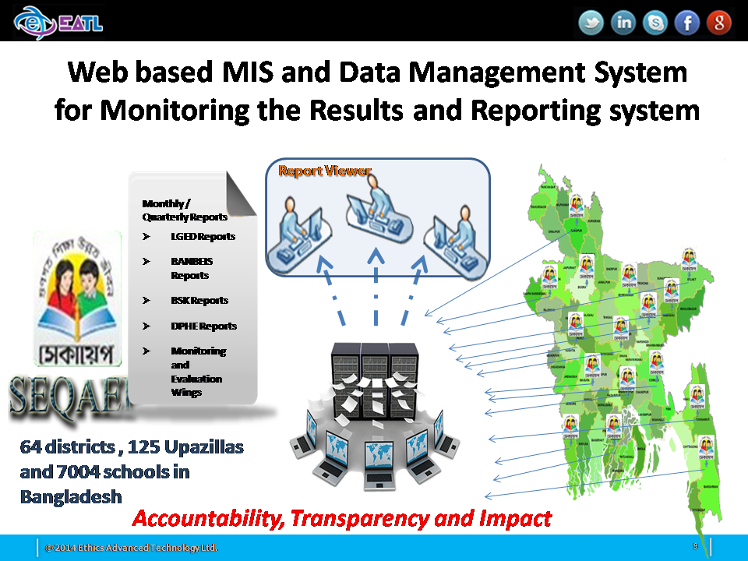

1. **Use Of ERP Solutions For Efficient And Cost Effective Delivery Of Products In Pharmaceutical Industries At Essential Drug Company Limited (EDCL), Funded By Ministry Of Health And Family Welfare (MoHFW)**
2. Designed and completed 14 ERP modules for EDCL project, including planning, management, PSM, supply chain, finance, accounts, budget control, Sales management, HR and office management modules.
3. It is customized modules that can be adopted in development and business sectors. It will provided effective tools for time, cost and business management options.
4. Customized modules that can be adopted in other pharmaceutical and social development ERP solutions
5. Provided effective tools for time, cost and business management process
6. Website: [www.edcl.gov.bd](http://www.edcl.gov.bd)

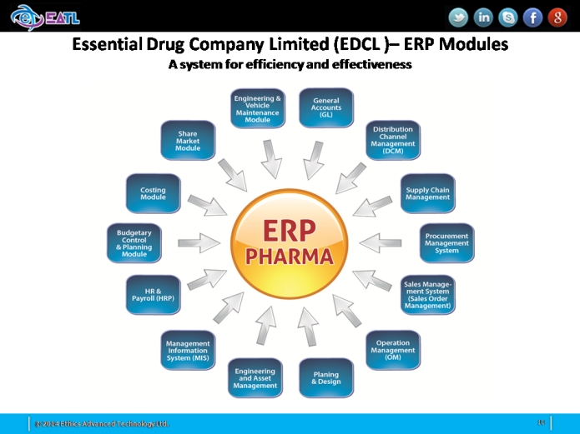

1. **Using Mobile Through Voice Call In Health Awareness For Behavior Change & Utilization Of Services In Community Clinic**
2. Working with MOHFW, BTRC and all telecom operators for utilization of mobile voice call in improving health awareness & & utilization of services at community clinic
3. Use of mobile technology for awareness building, behavior change and linkages with services
4. All upazilas and all Community Clinic areas with 6 corer population covered, funded by MOHFW
5. Collaboration with multiple stakeholders for local level utilization of health services
6. Managed through community clinic project and Director General of Health Services
7. Project duration was 6 months from June-Nov 2013, [***http://www.communityclinic.gov.bd***](http://www.communityclinic.gov.bd)***.***

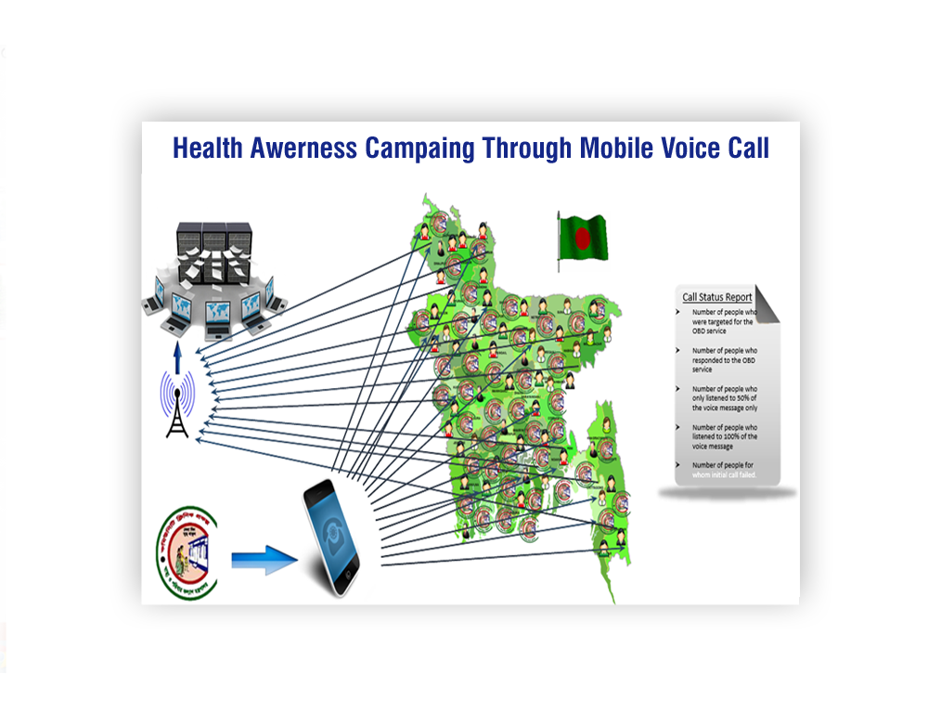

1. **Partnership With National ICT Awareness, Capacity Building And Mobile Application Development Project, Funded By Government Of Bangladesh**
2. Mobile Application awareness development and capacity building project, funded by MOICT and implemented by EATL & MCC.
3. Mobile Application Idea Generation Contest- with all government ministries
4. Mobile Apps Idea Collection
5. Apps Sensitization – Boot Camp (7 Divisions)
6. Digital Content Creation for Teaching
7. Apps Development Training (64 districts)
8. Mobile application ready One office One app
9. National Mobile App Championship
10. Resource Portal (<http://www.nationalappsbd.com>)

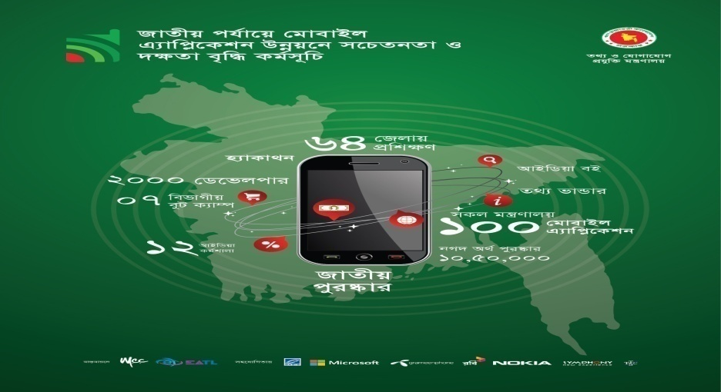

1. **ICT Solutions For Development Organization For Enhancing Impact At Scale (NGOs And Non-Government Institutions)**

EATL is also working with national and international NGOs like ORBIS, HASAB in education and health sector for using ICT solutions for supporting development programs for impact such as in reproductive health education, eye health, HIV/AIDS and linkages with services. Currently, EATL is working with web MIS, mobile solutions, Call center & IVR, Patient reminder solution and data management solutions for effective delivery of services.



1. **Academic And Hospital Information Management Solutions For Private Medical Colleges & Hospitals**

We have started working with private medical colleges, hospitals and other institutes in Bangladesh for providing ICT services and solutions. Initially 5 private medical colleges and hospitals are planned systematically for providing academic and campus management solution for medical colleges and Hospital Information Management solutions for effective services with its monitoring and back up support. The software has been deployed in the International Medical College and Hospital (IMCH), Tongi. We are in the process of deploying extensive software package a few others hospitals.

Website - <http://www.imchbd.com/>

1. **Bank And Financial Institutions**

We have reputed delivery in banking sector such as Rupali bank automation, HR management and use of integrated MIS for reporting system and also expanding to other financial institutions.

1. **Collaboration and Partnership with Universities for research & development for ICT high impact Solutions**

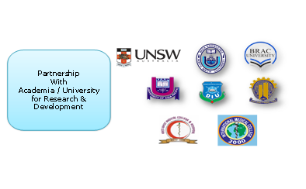

1. **EATL- Prothom Alo mobile Apps development Contest - 2014**

EATL has launched first ever mobile apps store in Bangladesh in 2012 and committed to develop high quality, context specific and local langugae mobile applications with enagement of brightest talents for supporting socio-economic development. It has estanhlished colalboration with internationals apps stores, mobile apps developers, universities, ICT industries, donors and Government.

**“EATL-Prothom Alo Apps Competition -2014”** titled as “Notun Sristir Sondhane” was inaugurated in 29 June 2013 in a flamboyant night held at the Balcony, Pan Pacific Sonargaon Hotel. EATL Apps, the first ever apps store in Bangladesh and The Daily Prothom Alo, the leading newspaper of the country are working collaborate in this event for creating innovation and opportunities for our brightest talents.

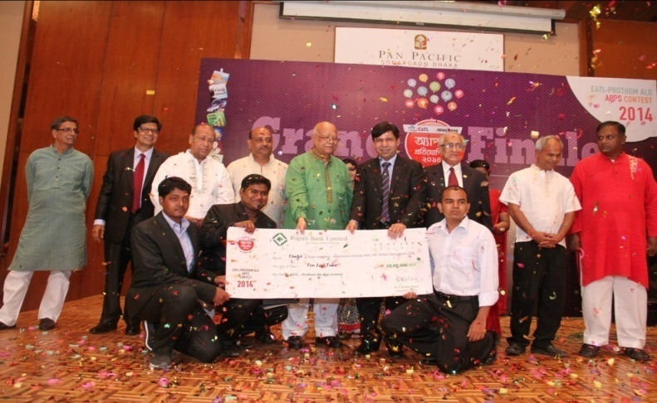

Grand Finale with Mr. Abul M A Muhith, Hon’ble Finance Minister and M A Mubin Khan, MD, EATL

1. **EATLApps Store**

EATL is the 1st company in Bangladesh to launch the first mobile app store in 2012. More than 100 apps are available in more than 11 categories. The specialty of these apps is that all the apps are developed using the local language ‘Bangla’ addressing the local context.

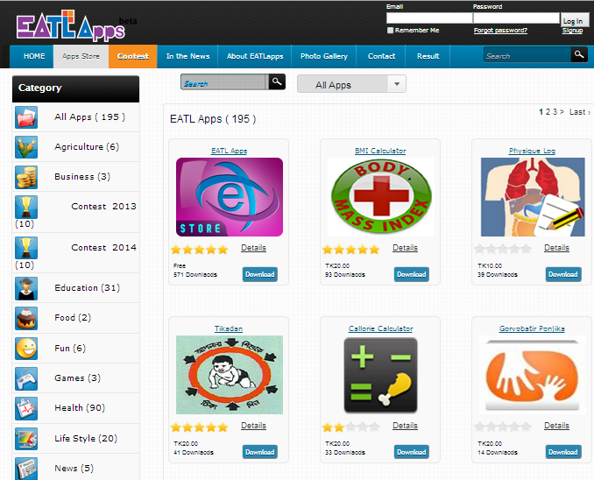

Complete company profile is attached in **Annexure – 1**

## REFERRED CLIENT LIST

|  |  |
| --- | --- |
| Sl. | **Client Name** |
| 1 | Secondary Education Quality Access Enhancement Project (SEQAEP) |
| 2 | Bangabhaban |
| 3 | Community Clinic |
| 4 | Essential Drugs Company Limited (EDCL) |
| 5 | Palli Karma-Sahayak Foundation (PKSF) |
| 6 | International Medical College &Hospital (IMCH) |
| 7 | Bangladesh Agriculture Research Institute (BARI) |
| 8 | National AIDS/STD Programme (NASP) |
| 9 | Ministry of Posts, Telecommunication and Information Technology |
| 10 | TeleTalk |
| 11 | HASAB |
| 12 | ORBIS |
| 13 | ZISKA Pharmaceuticals Limited |
| 14 | Bangladesh Parjatan Corporation |
| 15 | Biman Bangladesh Airlines |
| 16 | Department of Youth Development (IMPACT Project) |
| 17 | Bangladesh Shilpa Bank |

## LEGAL DOCUMENTS

For legal document please see **Annexure – 2**.

## FINANCIAL CAPABILITY AND COMMITMENTS

EATL is financially capable to handle this type of large projects and it’s been proven in the past works completed by EATL.

## CORE SERVICE AREAS

## EATL INDUSTRY EXPERIENCE

# DETAILED METHODOLOGY

Ethics Advanced Technology Limited applies a generalized work plan to each project that is undertaken by the organization. Although variations may arise in the sequence of phases in this workflow (due to the Choice of methodology applied for a specific project) all phases of this workflow are covered in one form or the other.

## HOW DO WE WORK

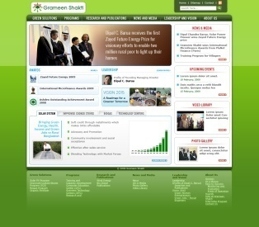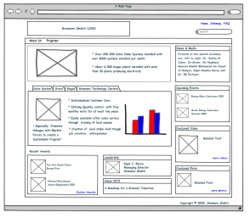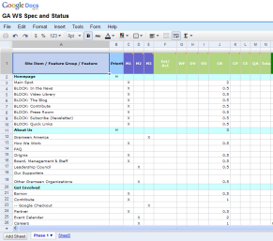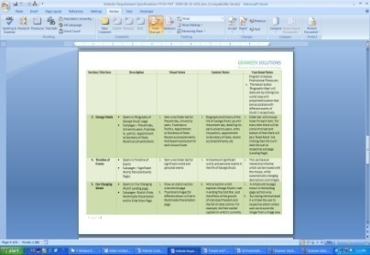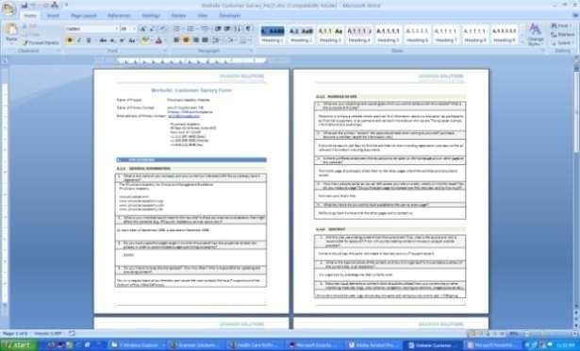

## PHASES OF DEVELOPMENT

During the project life cycle, EATL steps through a number of phases of development. The general sequence of these phases is outlined in the following sub-sections. Each of the major activities and outputs produced by an individual phase are also listed.

### ENVISIONING PHASE

The major activities that are conducted within this phase are as follows:

|  |  |
| --- | --- |
| **ACTIVITY** | **DESCRIPTION** |
| Elicitation | Collection of preliminary information by visiting the client organization and performing personal interviews of key individuals within the organization. |
| Analysis (Preliminary) | Analysis of scope of application based on information from the preliminary investigation. |
| Solution Vision | Formulation of a solution vision |
| Proposal | Formulation of a proposal statement |

The main objective of this phase is to gain an overall perspective of the problem and to draw up an initial plan for the solution. The primary outputs from this phase of the project life cycle are:

I. Solution Vision Statement.

II. Proposal Statement.

### PLANNING & DESIGN PHASE

The planning and design phase is primarily concerned with the comprehensive gathering of requirements and the designing of the initial model for an application. Activities that are conducted at this phase are listed on the following page:

|  |  |
| --- | --- |
| **ACTIVITY** | **DESCRIPTION** |
| Conduct Personal Interviews | Interview focus groups at client organization in order to gather detailed information regarding internal processes. Specifically the objectives of this activity is to:   * **I**dentify business events * **I**dentify business input and outputs for each event * **D**etermine relationships between inputs and outputs * **D**etermine precedence of relationships between these events. |
| Instruction | Information gathering is also conducted by the instruction method. This method of gathering requirements entails a member of the client organization to walk through the primary business processes as if training the interviewer. |
| Analysis | Analysis of collected requirements information and translation into technical criterion. |
| Use Cases | Use cases present system features and functionality from the perspective of the end-user. Presenting the use cases to the end user will allow EATL to verify that all features have been accounted for in the requirements gathering process. Use cases also help developers in the formulation of the system design. |
| Data Flow Diagrams | DFDs present the flow of information through the system. Progressively more detailed DFDs will be constructed for each module and sub-module in order to gain a basis on which to structure the system. Data Flow diagrams will be presented to clients in order to ensure that there are no inconsistencies or missing elements present in the application structure. |
| Preliminary Design | Formulation of a preliminary design for a solution (which includes the breakdown of the application into modules of functionality). |

The primary outputs from the Planning Phase are as follows:

I. Preliminary system structure document.

II. System Requirements Specification (SRS) report.

III. Prototypes.

A template for the SRS document is presented below:

|  |  |
| --- | --- |
| **ACTIVITY** | **DESCRIPTION** |
| Overview | Briefly goes through the overall functions and major features of the system. |
| Features | Lists the features of the application in greater detail |
| Technological Specifications | Describes the technologies and tools that will be used to develop the application. |
| Technological Requirements | This part of the SRS will list the major technological requirements of the system in terms of hardware and software. |
| User Categories | Defines the different categories of users that will be able to access the system and to what degree each category will have privileges. |
| Operating Environment | This section will detail the optimal operating conditions for the application and briefly mention maintenance of the system. |
| Constraints | Will list the design and implementation constraints for the solution such as scheduled time allocated for the development of the project. |
| Assumptions & Dependencies | Major assumptions and dependencies that EATL makes prior to the construction of the solution. |
| Stimulus & Response | Lists the events and/or stimulus sequences that will trigger a particular function. |
| Functional Requirements | Lists the requirements needed to implement each major feature. |
| Interface Design | Specifies design details for the user-interface |
| Interface Requirements | Lists the major requirements for the solution interface |
| Hardware Interface | Specifies the ideal layout for the solution in terms of hardware |
| Hardware Requirements | Specifies the minimum requirements necessary to operate the solution. |
| Non-Functional Requirements | Lists the non-functional requirements for the development of the system. An example maybe the performance requirements for the application. |

### DEVELOPMENT PHASE

The actual construction of an application occurs during this phase of the project life cycle. The general pattern of activities is presented below:

|  |  |
| --- | --- |
| **ACTIVITY** | **DESCRIPTION** |
| Instruction (Project Team) | Project manager will instruct team members on requirements and assign specific tasks. |
| Database Development | The system database for applications are designed and constructed at this phase. Information from requirements analysis, data flow diagrams and ER diagrams are utilized for this construction. |
| Prototyping | Prototyping of the application will continue at this phase in order to gain insight into actual requirements of clients. |
| Adjustments | If the need to adjust technical specifications arises based on feedback from clients, changes are made as required. |
| Coding | The actual coding of applications is handled in this activity. |
| Functional Level Testing | As the project team develops an application, tests are conducted to ensure that individual functions are performing tasks they were specified to do appropriately. |
| Debugging | If but EATL are located during the testing processes, they are corrected by the project team. |

The outputs from the development phase of the project life cycle are as follows:

I. Intermittent progress reports during the development cycle. These reports include information regarding overall progress of the project.

II. Completed database(s).

III. Completed modules.

### STABILIZATION PHASE

|  |  |
| --- | --- |
| **ACTIVITY** | **DESCRIPTION** |
| Validation Testing | These tests evaluate the completed solution to see if it is in compliance with the requirements of the client. |
| White Box Testing | Tests that fall under this category entail the analysis of the internals of applications. Data structures and execution paths are tested in order to locate any internal logic errors that may be present. Some of the tests that are conducted under this category are:  **B**asis path testing – tests prime execution paths of application.  **C**ondition testing – tests the conditional statements of the applications (if-else statements).  **D**ata flow testing – tests whether data is flowing through expected paths of application. |
| Black Box Testing | This category of testing involves an external view of applications and tests the functional requirements of the software. Some of the tests that are conducted under this category are: Boundary value analysis – tests minimum and maximum input values for fields on the application. Tests will also be conducted to see how gracefully application handles invalid data input. |
| Stress Testing | This test evaluates the load that the system can manage before performance deteriorates significantly. |

The stabilization phase entails the comprehensive testing and debugging of completed systems in order to ensure that solutions are free of errors and in compliance with the requirements of the client. The following activities are conducted at this phase of the project life cycle.

The major outputs from this phase are as follows:

I. Test plan document.

II. Test reports which detail specifics of testing such as criterion and end results. Reports also

Includes details on the actions taken by EATL found during the testing process.

### DEPLOYMENT PHASE

The deployment phase of the project lifecycle **deals** with the implementation of constructed applications within the client organization. The major activities that are conducted within this phase are as follows:

|  |  |
| --- | --- |
| **ACTIVITY** | **DESCRIPTION** |
| Installation | This activity involves the installation of constructed applications at the client organization. |
| Deployment Testing | Tests are conducted in order to ensure that installed application functions are working appropriately. |
| Evaluation | Clients perform a final evaluation of installed systems at this point. If the system requires updates or modifications, EATL makes all attempts to meet the client’s requirements. |

The principal outputs from the deployment phase of the project life cycle include:

I. Completed application.

II. User manuals.

III. Operational Manuals.

IV. Submission of source code for applications in softcopy and hardcopy format.

### TRAINING PHASE

During the training phase, the end-users of a developed product are trained on various subjects related to the usage of the developed system.

|  |  |
| --- | --- |
| **ACTIVITY** | **DESCRIPTION** |
| Training | Following a successful installation and evaluation of a system, training courses are launched in order to train target users on subjects covering:  **D**atabase development and administration Application usage (installation, configuration, maintenance, and troubleshooting).  **T**he specific courses offered and level of content within each course depends upon a specific client’s requirements. |

The principal outputs from the Training phase of the EATL generalized work plan are as follows:

I. Training manual.

II. Conduction of courses.

## PROJECT MANAGEMENT METHODOLOGIES AND FRAMEWORK

EATL adheres to a number of methodologies that are espoused by the software engineering ideology. The choice of methodology to be applied upon a particular assignment greatly depends upon the nature of the project involved and is determined following a thorough analysis of the project’s requirements and organizational business processes. This is because particular specifications may be especially suited to the utilization of a particular category of software engineering methodologies, whereas another assignment may be suited to the utilization of a different category of methodologies. The most frequently utilized methodologies applied by EATL are described in the following sub-sections of the document. Four main models are frequently utilized by EATL. These Models are:

* Agile Development Model (SCRUM).
* Incremental Model.
* Spiral Model.
* Prototyping Model.

Circumstances under which the various methodologies are applied are also included in the model descriptions.

### AGILE DEVELOPMENT MODEL (SCRUM)

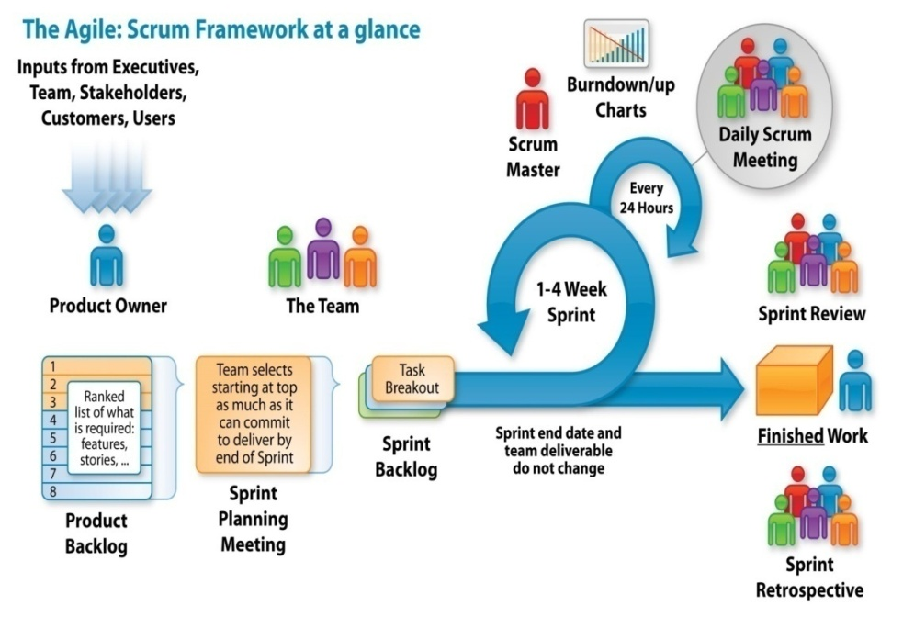

Figure: Scrum processes

### PROTOTYPING MODEL

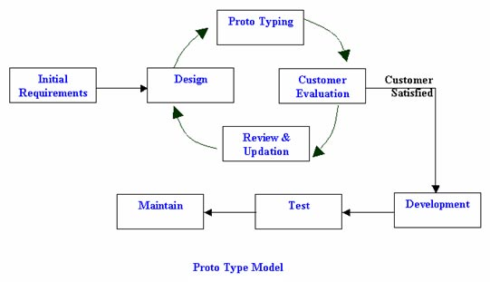

Figure: General process flow of the Prototyping mode

### INCREMENTAL METHODOLOGY

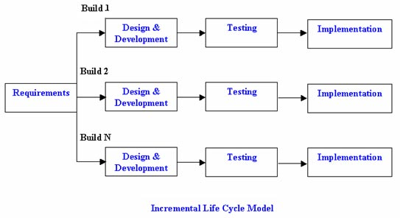

Fig: Basic flow of processes utilizing the Incremental methodology

### SPIRAL MODEL

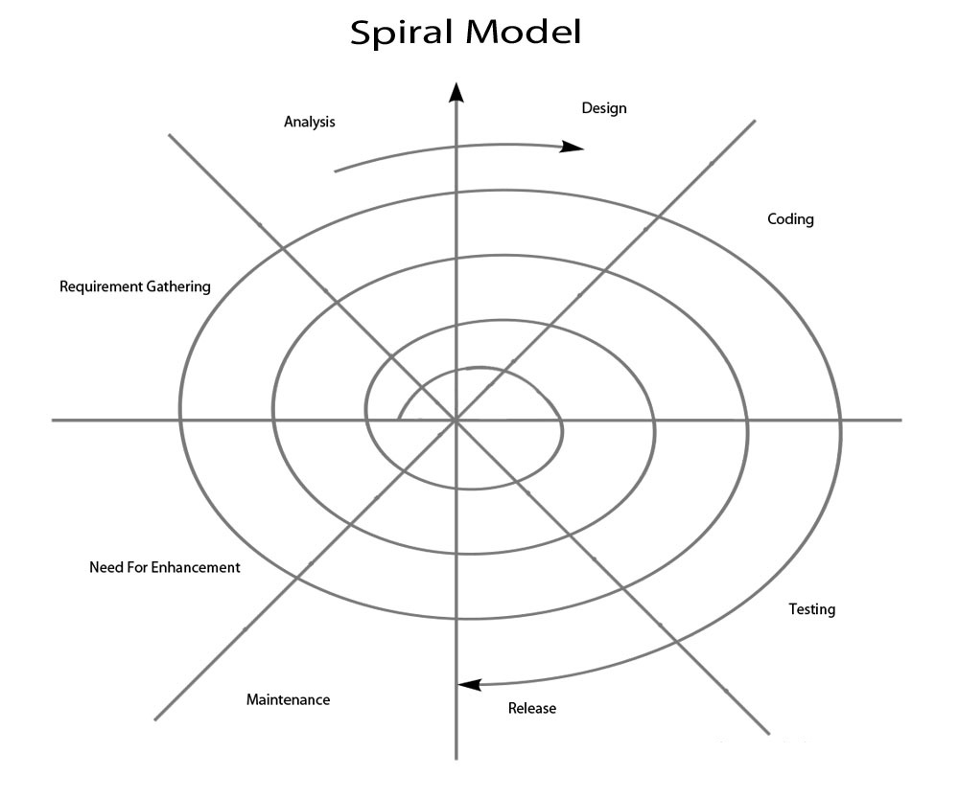

Fig: General flow of processes in the Spiral Model

## PROJECT MANAGEMENT PLAN

# IMPLEMENTATION

## PROPOSED HIGH LEVEL SOLUTION ARCHITECTURE

The Solutions Architecture is expressed using a number of different viewpoints to describe the target architecture required to fulfill the identified requirements including: Logical and Physical architectures. We solution architecture and technology standards will ensure we have a fit for purpose solution and that any exceptions are captured and agreed at the appropriate level.

This Solutions Architecture focuses on the live operating environment aspects of the overall solution.

### LOGICAL ARCHITECTURE

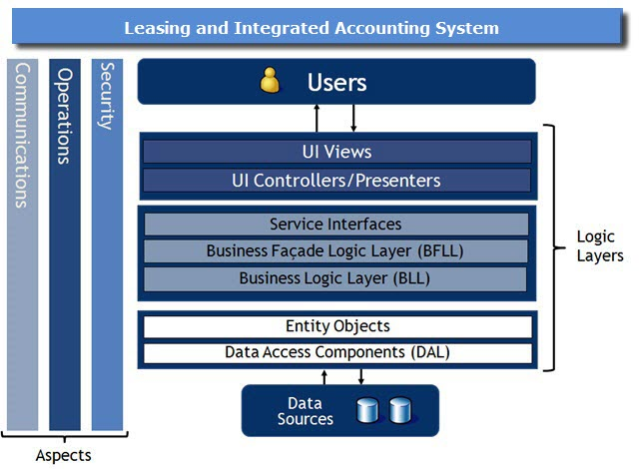

## PROPOSED TIMELINE

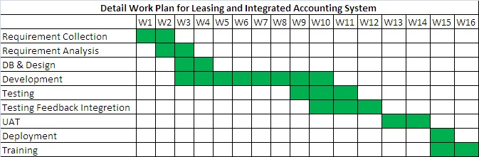

## SOFTWARE QUALITY ASSURANCE METHODOLOGIES AND TECHNIQUES

EATL is working with the ISO-9001 (attached at **Annexure - 2**) certification consultants that provide a clear definition of what an organization should do to promote behaviors that lead to improved and quality performance. It helps us identify and achieve measurable business goals, build better products, keep customers happier, and ensure that we are working as efficiently as possible.

Software quality assurance (SQA) is a planned and systematic pattern of actions necessary to provide adequate confidence that a software product conforms to requirements during software development. SQA consists of methodologies and techniques of assessing the software development processes and methods, tools, and technologies used to ensure the quality of the developed software. SQA is typically achieved through the use of well-defined standard practices, including tools and processes, for quality control to ensure the integrity and reliability of software. This special issue serves as a platform for researchers and practitioners to present theory, results, experience, and other advances in SQA.

Software testing is an investigation conducted to provide stakeholders with information about the quality of the product or service under test. Software testing can also provide an objective, independent view of the software to allow the business to appreciate and understand the risks of software implementation. Test techniques include, but are not limited to the process of executing a program or application with the intent of finding software bugs (errors or other defects).

Software testing can be stated as the process of validating and verifying that a computer program/application/product:

* Meets the requirements that guided its design and development,
* Works as expected,
* Can be implemented with the same characteristics,
* Satisfies the needs of stakeholders.

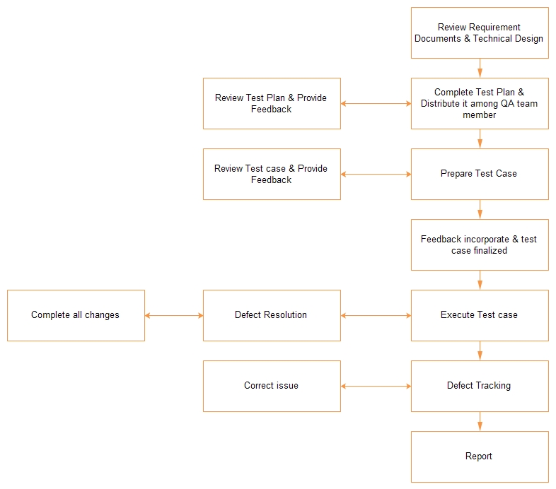

Software testing, depending on the testing method employed, can be implemented at any time in the software development process. Traditionally most of the test effort occurs after the requirements have been defined and the coding process has been completed, but in the Agile approaches most of the test effort is on-going. As such, the methodology of the test is governed by the chosen software development methodology.

### TESTING METHODS WHICH WILL BE FOLLOWED BY EATL

### TESTING LEVELS WHICH WILL BE FOLLOWED BY EATL

### TESTING TYPES WHICH WILL BE FOLLOWED BY EATL

### TESTING PROCESS WHICH WILL BE FOLLOWED BY EATL

#### AGILE OR EXTREME DEVELOPMENT MODEL

In contrast, some emerging software disciplines such as extreme programming and the agile software development movement, adhere to a "test-driven software development" model. In this process, unit tests are written first, by the software engineers (often with pair programming in the extreme programming methodology). Of course these tests fail initially; as they are expected to. Then as code is written it passes incrementally larger portions of the test suites. The test suites are continuously updated as new failure conditions and corner cases are discovered, and they are integrated with any regression tests that are developed. Unit tests are maintained along with the rest of the software source code and generally integrated into the build process (with inherently interactive tests being relegated to a partially manual build acceptance process). The ultimate goal of this test process is to achieve continuous integration where software updates can be published to the public frequently.

This methodology increases the testing effort done by development, before reaching any formal testing team. In some other development models, most of the test execution occurs after the requirements have been defined and the coding process has been completed.

#### PROPOSED TEST PLAN FOR THE DEVELOPMENT

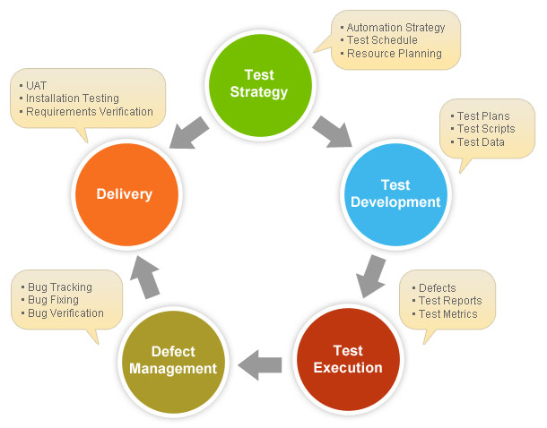

# TECHNICAL APPROACH AND SOLUTION

Design, develop, test, deploy and maintain the Web-based Case Management software with the key attributes of criminal cases focusing to assemble and captured in a common structure. The information will be primarily based on different registers known as GR, NGR & CR as well as other registers maintained at different courts so a particular case can be tracked as a single entity as it moves through different stages of its life cycle.

## COMPONENTS OF THE TASK

### LEASING & INTEGRATED ACCOUNTING SYSTEM

|  |  |  |
| --- | --- | --- |
| **Sl. no.** | **Items** | **Summary** |
| 1 | General Configuration | General Configuration is the major part of **Leasing & Integrated Accounting System**. This system provide the integrated solution for keeping track of the company information and it’s a one way process for setup the company rules and regulation. It includes all branches as well.  Features:   1. Company Information 2. Branch Information (Multiple Branch maintenance by one database) 3. Define Accounting Method 4. Define Accounts Posting Method 5. Setting Accounting Period 6. Cards    1. Customer Information    2. Vendors/Supplier Information. 7. Analyzing Business Rules. |
| 2 | Integrated Accounting System | It automatically prepares the financial Statement like Cash Book, Bank Book, Ledger, Balance Sheet, Trial Balance, Profit and Loss, Budgeting and analysis etc.  Features:   1. Preparing Chart of Accounts as Branch wise 2. Control & Ledger Accounts Creation (Ledger/Group Control Account) 3. Define Cash & Bank Account 4. Define Accounts Receivable, Accounts Payable 5. Define Purchase Accounts 6. Define Sell Accounts 7. Define Bank Account Information 8. Bank Accounts Link to Chart of accounts 9. Cheque Book and Cheque Leaf Information 10. Prepare Payment, Receipt and Journal Voucher. 11. Voucher Posting 12. Define Fiscal Year   Reports:   1. Chart of Accounts List 2. Transaction History 3. Journal, Ledger, Balance Sheet, Trial Balance Statements 4. Cash & Bank Book Statements 5. Voucher Entry Report 6. Accounts Receivable and Accounts Payable Statements 7. Profit and Loss statement |
| 3 | Leasing Management | Leasing Management is important part of **Leasing & Integrated Accounting System** this system manages their leased, tracking of customer ledger and sales collection history.    Features:   1. Leasing agreement system 2. Customer Ledger maintain 3. Monthly collection   Reports:   1. Leasing agreement sheet 2. Customer Ledger 3. Monthly sales collection |
| 4 | Security Management | 1. Group Creation, Deletion and Updating with change password, termination option 2. User Creation, Deletion and Updating with change password, termination option 3. Providing Permission Group and user basis |

## TECHNOLOGY PLATFORM

**Development platform for Leasing & Integrated Accounting System:**

**EATL** developed with new technology, and is always looking for ways to improve the quality of their own products and the service they are able to offer their clients. It will support all the platform of web and run both in Internet and intranet

* Operating System: Windows Server
* Development Technology: Microsoft Visual Studio Framework
* Database: MS SQL Server 2008 / 2012
* IDE: Visual Studio 2010

**Development environment:**

* **Development Language:** ASP .Net with C#
  + **Framework Version:**.Net Framework 4.0
* **Database:** SQL Server 2008 / 2012

**Data Backup / Recovery System:**

* The system has its own technology for Data backup and Data restore system from recovery of any disaster

## DESIGN AND DEVELOPMENT OF THE SOLUTION

* 1. System design finalization
  2. Review and testing the requirements with time
  3. Testing the performance of the solution
  4. Development of the software system as per existing policy
  5. Development of reporting format for automatic reporting system

## SECURITY AND ACCESS CONTROL

Code level and database level access control mechanism will be developed to prevent the system from unauthorized access. No unauthorized person will have access to database and modification of information.

## QUALIFICATION OF EATL FOR THIS PROJECT

1. EATL is a leading ICT organization in Bangladesh that was established in November 1999.
2. EATL having track record in successfully working in the development of online database application software, management information systems and successfully designing and developing projects related to website. Below are the lists:
3. Web MIS for Secondary Education Quality and Access enhancement Project (SEQAEP), <http://www.seqaep.gov.bd/>
4. Community Clinic based MIS for RCHCIB (Community Clinic Project), <http://www.communityclinic.gov.bd/>
5. Hospital Information Management System for International Medical College and Hospital (IMCH), www.imchbd.com
6. HIV/AIDS and STD Alliance Bangladesh (HASAB), <http://www.hasab.org/>
7. National AIDS/STD Programme (NASP), <http://www.bdnasp.org/>
8. <http://www.eatlbd.com/eatl/>
9. The Office of Honorable President of Bangladesh (Bangabhaban)
10. <http://www.eatlapps.com/>
11. Bangladesh Agricultural Research Institute (BARI), <http://www.bari.gov.bd/>
12. Human Resource Management System for Rupali Bank Limited
13. ERP Pharma for Essential Drugs Company Limited (EDCL)
14. Doctor’s Profile Management for Ziska Pharmaceuticals Ltd.
15. Palli Karma Sahayak Foundation (PKSF)
16. EATL have experience in developing MIS in open standard web development environment because the above projects have been developed by using PHP, ASP.Net.

# WARRANTY, MAINTENANCE AND SUPPORT

## WARRANTY

* One year warranty will be provided by EATL

## MAINTENANCE

* One year maintenance support will be provided by EATL

## SUPPORT

* We will provide one database administrator and a software engineer on fulltime basis, if necessary. Since we have large development setup, we will be able to provide a number of support stuff on call basis if required.

# CONCLUSION

Development of Case Management will greatly increase the effectiveness and efficiency of the court related activities. The Leasing & Integrated Accounting System will Enhance cooperation and coordination through better and easy access of required information in relation to pending criminal cases as well as by enabling uniformity and single version of the information for all. It will greatly reduce service time and resource utilization to generate various reports for screening, prioritizing and performance monitoring. Also it will improve overall transparency & accountability as the current status and progress would be easily visible to key stakeholders from management at district level and national level.

The services mentioned in the circular are very much familiar to the EATL team. EATL has the solid experiences in building different kinds of web based solutions for Government and NGOs. In this type of information management projects, most of the times, data merging or data migration is a big challenge, since EATL has past experience of doing data migration in different Government projects; it is very much viable for EATL experts to design and implement this project.

We believe in collaboration, innovation and responsive services with our partners and clients. Finally, our experiences in working with the Government organizations will greatly help both parties to fructify the goals of this project.

# FINANCIAL PROPOSAL

## PRICE OFFER

|  |  |  |  |  |
| --- | --- | --- | --- | --- |
| SL. | Description &Details | | Quantity | Total Amount  Tk. |
| 1. | Leasing & Integrated Accounting System | | 1 | **500,000.00** |
|  | VAT (4.5%) | | 1 | **22,500.00** |
|  | Total Amount, Including VAT | |  | **522,500.00** |
|  | Total Amount in BDT (In Word) | **Five laces twenty two thousand five hundred taka only.** | | |

|  |  |
| --- | --- |
| Signature |  |
| Name of Supplier | **Muhammad Ifteraz Hafez**  Project Manager  **Ethics Advanced Technologies Limited** |
| Date | August 16, 2014 |